Retiree Council 9 Membership Form (2023-2024)
Which Sub-council do you belong to? These are based upon where the district you retired from was located. The JLCNR area is Jefferson-Lewis retirees, the FSNUR is Franklin- St. Lawrence, CVCR is Champlain Valley, and SANR indicates Southern Adirondack NYSUT Retirees.
A retiree may join a sub-council where they now live if more convenient. (And if you like an activity in another sub-council, sign up!)
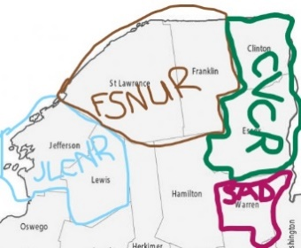
If you have not completed and sent in your participation fee for the year for your RC and Sub-council complete this and mail to Jodi Kelley c/o RC 9 Membership 513 Washington Street Suite #3 Watertown, NY 13601
Membership year is July 1 to June 30 following School calendar year.

Name: Date of Birth:
Phone, include area code:
(home) (cell)
Street Address:

City:________________________________________ State:_______ Zip code:__________________

E-mail address:
Email used strictly for Union communication for RC and our affiliates.

School district retired from: Year Retired:
Check your sub-council (unsure- look at map on first page) and pay the participation fee indicated for it.
Make check out to RC 9: $10 of participation fee goes to RC 9

___ CVCR $20 ___ FSNUR $20 ___ JLCNR $20 $___ SANR $20

Check Number: __________________ Date of Check:______________

Members over 80 do not need to pay a participation fee if you have contributed participation fee previously.
but need to complete annual form to be of Sub-councils and RC 9.

Mail form and check made out to RC 9 to: Jodi Kelley c/o RC 9 Membership 513 Washington Street Suite #3 Watertown, NY 13601

If you are part of CVCR: Our representative on the CEWW Health Insurance Advisory Committee will place you on the email list for health information. Do you have CEWW Empire (YES or NO)?

