**CVCR … It’s Almost a Wrap**

As one reflects back to the first meeting of the season in September, it’s been a very busy “year” for the Champlain Valley Council of Retirees (CVCR). One goal has been to have a more digital presence for the organization. The process has begun. For those that prefer, we now offer online registrations for our luncheon meetings and we have started a website. Work on that is definitely ongoing. A traditional project has been to collect donations at every meeting for the local food shelf which has been very successful. The membership also decided to double the amount of our two annual scholarship awards from $500 to $1000. The selection process for the new recipients has begun and they will be determined by the end of the school year.

Besides offering the expected opportunity to catch up with friends and former colleagues, the standard format for our monthly gatherings starts with a business meeting at 11:00 AM, followed by lunch and a presenter. Our business meetings usually provide the members with updates regarding important issues on the national and state levels such as potential threats to Social Security and Medicare benefits, the status of our regional health insurance benefits, and so on. This past fall, Assemblyman Billy Jones (District 115) stopped by one of our meetings to update us regarding pending legislation important to educators and retirees.

After lunch presentations also have offered a variety of information. Speakers have included Janine Scherline, of the grant-awarding Adirondack Foundation; Denise Sypek, Director of the North Country Teacher Resource Center, who reported the status of some of the programs offered there; Dan Ladue, a retired educator and author gave us a preview of his recent book, “Bold and Courageous: 25 North Country New York Women and Their Exceptional Contributions”; Jamie Sutton, Center Manager, brought information about the services and programs available at the AARP sponsored North Country Senior Planet; Jacqueline Madison, President of the North Country Underground Railroad Historical Association, told us the role that the Champlain Valley played in this phase of our history; and Eli Swartzberg spoke of the Samuel F. Vilas Home in Plattsburgh and the Champlain Valley Senior Community in Willsboro. Upcoming presentations will feature Rosemary Souza-Botten and Vickie Giroux regarding our health insurance, and retired teacher Jean Welch, currently active with the Champlain Valley Quilters Guild New York. December was a more social atmosphere with the acoustic vocal group, Towne Meeting, once again performing some holiday favorites. There was singing and laughter aplenty.

CVCR meets at the MHAB Conference Center, 14 Dormitory Drive,  Plattsburgh, NY 12903. We meet on the second Monday of each month from September to June. Please feel free to join us as we wrap up another successful year.

Gary VanCour, co-chair

CVCR

Jackie Madison speaking to CVCR about the role of the Underground Railroad used by runaway slave in the Champlain Valley.

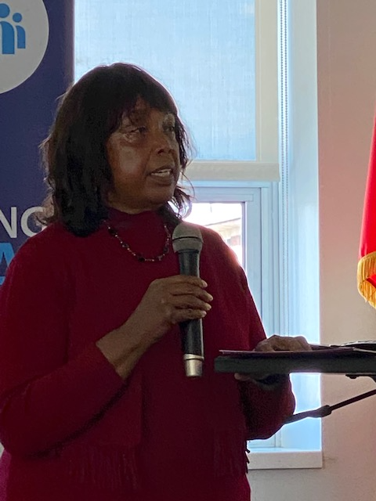

Gary VanCour, co-chair of CVCR and Jackie Madison, President of the North Country Underground Railroad Historical Association

